GOAT_666 Online Travel Platform
Software Requirements Specification (SRS)
Document Information | Entry
Document Version | V1.0
Date Written | October 17, 2026
Authors | [Ruizhi Liu], [Xinyang Zhang], [Wenjie Yan], [Longzhe Lin], [Qihang Peng]
Reviewer | [Zihan Zhao]
Project Team | GOAT_666

Note: This document was prepared based on the Project Definition and the course assignment requirements, following the requirements expression principles of GB/T 9385-2008, Specification for Computer Software Requirements, and GB/T 45802-2025, Systems and Software Engineering—Life Cycle Processes—Requirements Engineering. Functional requirements FR-01–FR-12, scenarios SC-01–SC-06, pages UI-01–UI-08, and acceptance tests AT-F01–AT-F10 are referenced consistently throughout. All initial release functions have verifiable requirements; additional functions are marked “Extension.” Unfinished items are recorded in Chapter 6.

Contents
Contents 2
1. Introduction 4
1.1 Purpose 4
1.2 Project Background 4
1.3 Scope and Boundaries 4
1.4 Terms and Abbreviations 5
1.5 References 5
2. General Description 6
2.1 Product Goals and Application Scope 6
2.1.1 Product goal 6
2.1.2 Application scope 6
2.1.3 Product outlook 6
2.2 User Roles 6
2.3 Operating Environment and Constraints 6
2.4 User Scenarios 6
SC-01 Visitor Searches for Attraction Guides 7
SC-02 User Makes a Simulated Booking 7
SC-03 Publish a Travel Note and Interact 8
SC-04 Administrator Maintenance 8
SC-05 User Cancels an Order and Views a Simulated Refund 8
SC-06 Registered users use the AI travel assistant [Extension] 9
3. Specific Requirements 9
3.1 Overall Class Diagram 9
3.2 Usability Requirements 11
3.3 Security and Access Requirements 11
3.4 Other Quality Constraints 12
4. Interface Prototypes 12
4.1 Page List and Navigation 12
4.2 Key Page Prototypes 13
5. Functional Description and Acceptance Verification 16
5.1 Detailed Functional Description 16
FR-01 Account Management 16
FR-02 Browsing Travel Information 17
FR-03 Search 17
FR-04 Hotel and Ticket Product Search 17
FR-05 Simulated Booking (Place Order) 18
FR-06 Order Management 18
FR-07 Travel Notes 19
FR-08 Comments, Ratings, Favorites 19
FR-09 Platform Management 20
FR-10 Personalized Recommendations 20
FR-11 Content Moderation and Usage Statistics 20
FR-12 AI Trip Assistant 21
5.2 Input and Output Formats 21
5.3 Interface Acceptance Criteria 22
5.4 Functional Acceptance Criteria 22
6. Process Records and Revisions 23
6.1 Design Decisions, Issues, and Solutions 23
6.2 User Validation Record 23
6.3 Unfinished Items and Follow-up Updates 24
6.4 Requirements Traceability and Consistency Check 24

Introduction

Purpose
This document defines the business requirements, user behaviors, functional rules, exception handling logic, and acceptance criteria for the GOAT_666 online travel platform. For the development team, this specification serves as the requirements baseline for system design and coding, ensuring that all members maintain a consistent understanding of the product logic. For testers, this document provides the basis for writing test cases and conducting functional and interface validation. For course review instructors, this document constitutes a complete requirements deliverable for the software engineering course assignment. This specification is intended solely for the course practice project and shall not serve as a basis for commercial product delivery.

Project Background
Software name: GOAT_666 Online Travel Platform.
Project source: the third course assignment (software requirements analysis). The project team has 13 members. Five members in roles A–E prepared, integrated, and reviewed this specification; development, interface, and testing members helped check the content.
Problem to be addressed: Travel information is scattered across several platforms, making it time-consuming for visitors to find destinations, attractions, guides, and hotel and ticket information. Booking processes are unclear, and users cannot easily experience the full process without the risk of real payment. The platform also lacks a place to retain community content such as travel notes, comments, ratings, and favorites.
The platform provides a complete process from finding travel information to sharing travel experiences. Visitors can browse and search destinations, attractions, guides, hotels, and tickets. Registered users can select a date and make a simulated booking, view or cancel orders, and publish travel notes, comments, ratings, and favorites. Administrators maintain platform information and user content. After the basic functions are complete, the platform plans to add personalized recommendations, content moderation, usage statistics, and AI trip suggestions.

Scope and Boundaries
Scope | Content
Initial release | Accounts (registration, login, logout, edit profile); browse and search travel information; view hotel and ticket products; simulated bookings, order lookup, cancellation, and simulated refunds; publish travel notes and add comments, ratings, and favorites; administrator maintenance of attractions, guides, products, and user content.
Extensions | Personalized recommendations (FR-10); content moderation and usage statistics (FR-11); AI trip assistant (FR-12).
Explicitly excluded | Real payments and refunds; offline redemption; multiple languages or currencies; native mobile apps (initial release is browser-only); third-party OTA integration.
Note: This platform is a teaching project. Bookings and refunds are simulated and do not involve actual funds. See Section 1.4 for related terms.

Terms and Abbreviations
Term or Abbreviation | Meaning | First Used
Visitor | A user who has not logged in. Can browse and search destinations, attractions, guides, hotels, and tickets, but cannot place orders or publish content. | 2.2
Registered user | A regular user who has logged in. Can make simulated bookings, manage their own orders, and publish travel notes, comments, ratings, and favorites. | 2.2
Administrator | A platform role responsible for maintaining attractions, guides, products, and user content. | 2.2
Simulated booking | A booking process without real payment: after selecting a product, date, and quantity, the user places an order and the system creates an order and reserves inventory. | 2.4
Simulated refund | A refund amount calculated and displayed under the cancellation rules; no real funds are involved. | 2.4
Available quantity | The number of units of a product available for booking on a date (Inventory.availableCount). | 3.1
Guide | An article about travel to a destination (Guide). | 2.4
Travel note | An article about a trip published by a registered user (TravelNote). | 2.4
SRS | Software Requirements Specification. | 1.1
UML | Unified Modeling Language; used for the class diagram in this document. | 3.1
FR  NFR | Identifier prefixes for Functional Requirement  Non-Functional Requirement. | 3
SC | Identifier prefixes for Scenario | 2.4
UI | UI Prototype | 4
AT | Acceptance Test. | 5

References
No. | Title and Version | Source or Link | Purpose
1 | Third Course Assignment Requirements | https://bbs.csdn.net/topics/620549144 | Grading criteria and delivery requirements
2 | Project Definition (companion document) | Course materials | Functional boundaries and user flows
3 | GB/T 9385-2008, Specification for Computer Software Requirements (current) | https://std.samr.gov.cn/gb/search/gbDetailed?id=71F772D7FB12D3A7E05397BE0A0AB82A | Principles for preparing the SRS
4 | GB/T 45802-2025, Systems and Software Engineering—Life Cycle Processes—Requirements Engineering (current) | https://std.samr.gov.cn/gb/search/gbDetailed?id=36DE96AA3EACCD71E06397BE0A0A23D9 | Requirements engineering process and expression principles
5 | Specification Writing Assignments and Delivery Checklist | Course materials | Role assignments and delivery requirements

General Description

Product Goals and Application Scope

2.1.1 Product goal
Provide visitors with one place to look up destinations, attractions, guides, and hotel and ticket information; give registered users a risk-free simulated booking experience and community interaction; and allow administrators to maintain platform content.

2.1.2 Application scope
Accessible through a Web browser. Main users are students and general travelers interested in independent travel.

2.1.3 Product outlook
After the initial release completes the core process, add personalized recommendations, content moderation and usage statistics, and an AI trip assistant, forming a “search—book—travel—record” cycle.

User Roles
Role | Accessible Content | Main Tasks | Preconditions
Visitor | Browse destination, attraction, guide, and product lists and details | Find information; view prices and available quantities | No login required
Registered user | All visitor content plus simulated bookings, own orders, travel notes, comments, ratings, and favorites | Place and cancel orders, view simulated refunds, and publish interactive content | Logged in
Administrator | Platform administration area | Maintain attractions, guides, and products; handle user content | Administrator account

Operating Environment and Constraints
Operating environment: Modern Web browsers (latest versions of Chrome, Edge, and Firefox recommended), accessible on desktop and mobile browsers.
Technical constraints: The initial release is a Web application and does not connect to a real payment channel. Inventory is based on server data; quantities shown on pages are for display only. Dates use YYYY-MM-DD. Amounts are in Chinese yuan (¥), with two decimal places.

User Scenarios
All scenarios are described using “role and goal—trigger—preconditions—normal steps—exceptions or branches—outcome—related requirements.” Steps include only observable user and system behavior.

SC-01 Visitor Searches for Attraction Guides
Element | Content
Role and goal | A visitor wants to find attractions worth visiting and related guides for a destination.
Trigger | The visitor opens the platform home page.
Preconditions | No login required.
Normal flow | 1. The visitor enters “Hangzhou” in the home-page search box;  2. The system returns results for Hangzhou destinations, attractions, and guides;  3. The visitor clicks the “West Lake” attraction to view its details;  4. The visitor opens a related guide from the detail page.
Exceptions and branches | If no results are found, display “No related content found. Try another keyword.” Visitors can view all information without logging in.
Outcome | The visitor obtains attraction and guide information and can view related products.
Related requirements | FR-02, FR-03, UI-01

SC-02 User Makes a Simulated Booking
Element | Content
Role and goal | A registered user selects a product after searching, completes a simulated booking, and generates an order.
Trigger | The user clicks a hotel or ticket product on an attraction detail page or product list.
Preconditions | The user is logged in; the product is “Listed”; the selected date has available inventory.
Normal flow | 1. On the product detail page, the user selects the use date 2026-10-20 and quantity 2, then clicks [Simulated Booking];  2. The system checks login status, whether the product is listed, and whether the available quantity for that date is at least 2;  3. After validation, the system deducts 2 from the available quantity for that date, generates an order with status “Reserved” and its line item, and calculates total amount = unit price × quantity;  4. The system opens the order confirmation page and displays the order number, details, and total;  5. The user can view the order under “My Orders.”
Exceptions and branches | Not logged in: open the login page and return to product details after login;  Insufficient inventory: show “Insufficient inventory for the selected date. Adjust the quantity or date,” and do not create an order;  Invalid quantity (0, negative, non-integer, or above the available quantity): show an error and block submission;  Repeated click on [Confirm Order]: disable the button and use server-side idempotency so only one order is created;  Product delisted: show “This product has been delisted.
Outcome | One order with status “Reserved” is created, the available quantity for that date decreases, and the page shows the order confirmation.
Related  requirements | FR-04, FR-05, UI-02, UI-03, AT-F01–AT-F05

SC-03 Publish a Travel Note and Interact
Element | Content
Role and goal | A registered user publishes a travel note and receives comments, ratings, and favorites.
Trigger | The user clicks “Write a Travel Note” in the personal center.
Preconditions | The user is logged in.
Normal flow | 1. Enter a title and body and upload images;  2. Click Publish and the travel note enters the public list;  3. Other users can comment, rate it (1–5 stars), and add it to favorites.
Exceptions and branches | Ask users who have not logged in to log in; show a message if an image exceeds the limit; hidden content is not displayed.
Outcome | The travel note is publicly visible and accumulates interaction data.
Related requirements | FR-07, FR-08, UI-05, UI-06

SC-04 Administrator Maintenance
Element | Content
Role and goal | An administrator maintains platform information and user content.
Trigger | The administrator enters the administration area after logging in.
Preconditions | Logged in with an administrator account.
Normal flow | 1. Add or edit attractions, guides, and products;  2. Delist products that violate rules;  3. Hide travel notes or comments that violate rules.
Exceptions and branches | Show “Access denied” when a regular user tries to access the administration area.
Outcome | Platform content is maintained.
Related requirements | FR-09, FR-11, UI-07

SC-05 User Cancels an Order and Views a Simulated Refund
Element | Content
Role and goal | A registered user cancels their own “Reserved” order and sees the simulated refund.
Trigger | The user clicks [Cancel Order] on the “My Orders” page.
Preconditions | The order status is “Reserved,” and the user owns the order.
Normal flow | 1. The system verifies ownership (rejecting another user's order) and the current status (only “Reserved” orders may be cancelled);  2. The system calculates a simulated refund under the cancellation rules: cancel at least 3 days before the use date for 100%, 1–2 days before for 50%, or on the use date for 0%;  3. The system changes the order status to “Cancelled,” records refundAmount, and restores the available quantity for the date by the cancelled quantity;  4. The page shows “Order cancelled. Simulated refund of ¥xx returned (simulated),” and updates the status in the order list.
Exceptions and branches | Repeated cancellation: show “Order already cancelled; no further action needed”;  Completed order: cannot be cancelled;  Unauthorized access to another user's order: show “Access denied” without disclosing order content.
Element | Content
Outcome | The order becomes “Cancelled,” inventory is restored, and the refund amount is displayed under the rules.
Related requirements | FR-06, UI-04, AT-F06–AT-F08

SC-06 Registered users use the AI travel assistant [Extension]
Element | Content
Role and goal | Registered users want to quickly generate a reference travel itinerary based on their destination.
Trigger | Registered users can click on the "AI Trip Assistant" entry in the navigation bar.
Preconditions | The user account is already logged in; the platform has the corresponding scenic spots and travel guide data for this destination.
Normal flow | - The user accesses the AI itinerary assistant page (UI-08).  - The user enters the destination name, sets the number of travel days, and can optionally fill in travel preferences (such as natural scenery, food exploration, family leisure).  - The user clicks the "Generate Itinerary" button.  - The system reads the attraction and guide data within the platform, generates a structured itinerary plan, and displays recommended attractions and simple travel tips by day.  5. The user browses the generated itinerary, and can view the jump to the detailed page of the attractions within the itinerary.
Exceptions and branches | 1. AI service timeout: The page displays "The AI service is temporarily busy. Please try again later", and does not show invalid trips.  2. Destination lacking available platform data: It shows "This destination does not have sufficient reference materials. No itinerary can be generated. Please change the destination".  3. Visitors who are not logged in directly accessing the AI assistant page: Redirect to the login page, and then return to the AI assistant page after logging in.  4. User inputs an empty destination: It prompts "Destination is a required field. Please enter the destination".
Outcome | Normal: The page displays the itinerary reference plans generated by AI, categorized by days, and allows for navigation to the details of the corresponding attractions;  Exception: A clear prompt is given, and no blank or garbled itinerary will be output.
Related requirements | FR-12、UI-08、AT-F10

Specific Requirements

Overall Class Diagram
Figure 3-1 is the overall class diagram. It covers core objects including users, destinations and attractions, guides, hotel and ticket products, inventory, orders, travel notes, comments, ratings, and favorites. Class names, states, and functional descriptions are consistent throughout the document.
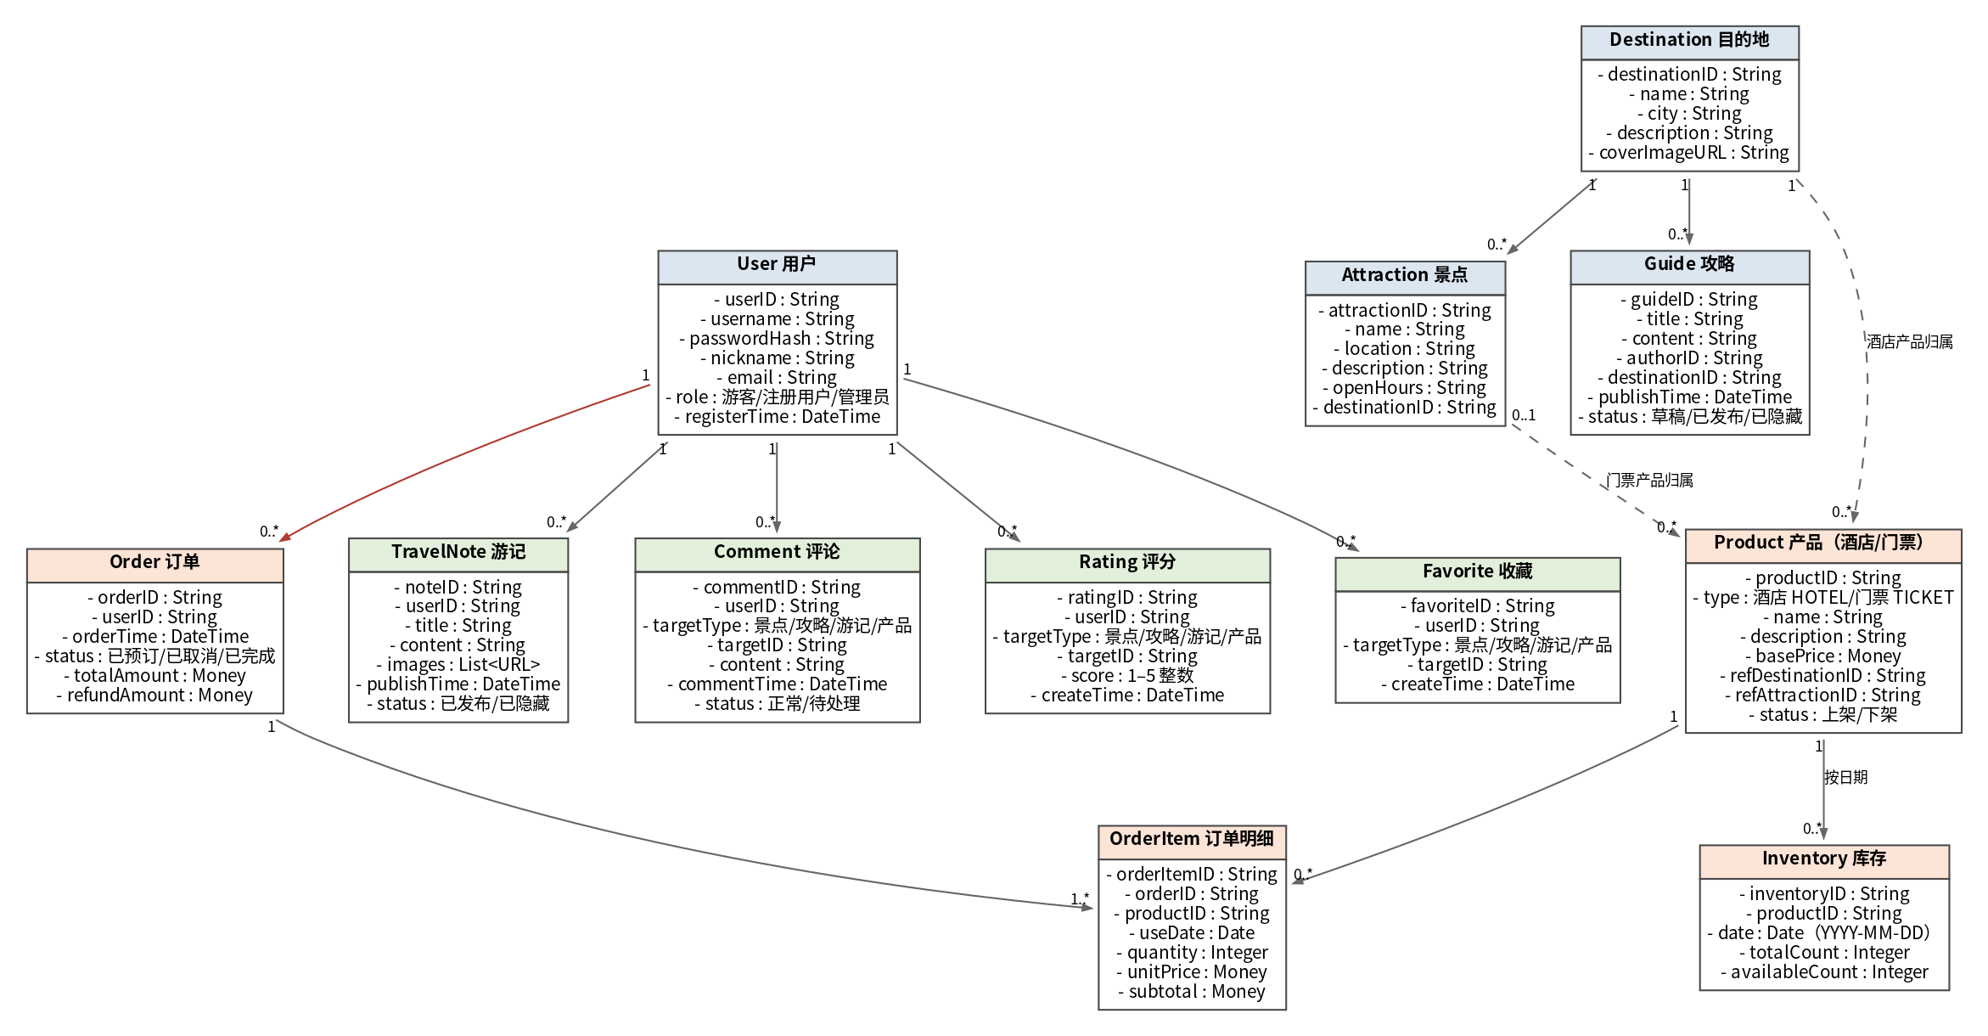
Figure 3-1 Overall Class Diagram

Class or Object | Key Attributes | Main Relationships and Multiplicity
User | userID, username, passwordHash, nickname, email, role (visitor/registered user/administrator), registerTime | 1—0..* Order; 1—0..* TravelNote; 1—0..* Comment; 1—0..* Rating; 1—0..* Favorite
Destination | destinationID, name, city, description, coverImageURL | 1—0..* Attraction; 1—0..* Guide; 1—0..* Product (hotel product association)
Attraction | attractionID, name, location, description, openHours, destinationID | Belongs to 1 Destination; 0..1—0..* Product (ticket product association)
Guide | guideID, title, content, authorID, destinationID, publishTime, status | Belongs to 1 Destination
Product | productID, type (hotel/ticket), name, description, basePrice, refDestinationID, refAttractionID, status (listed/delisted) | 1—0..* Inventory; 1—0..* OrderItem
Inventory | inventoryID, productID, date, totalCount, availableCount | Belongs to 1 Product; productID + date is unique
Order | orderID, userID, orderTime, status (reserved/cancelled/completed), totalAmount, refundAmount | Belongs to 1 User; 1—1..* OrderItem
OrderItem | orderItemID, orderID, productID, useDate, quantity, unitPrice, subtotal | Belongs to 1 Order; references 1 Product
TravelNote | noteID, userID, title, content, images, publishTime, status | Belongs to 1 User
Comment | commentID, userID, targetType, targetID, content, commentTime, status | Belongs to 1 User; polymorphic target (attraction/guide/travel note/product)
Rating | ratingID, userID, targetType, targetID, score (1–5), createTime | Belongs to 1 User; polymorphic target
Favorite | favoriteID, userID, targetType, targetID, createTime | Belongs to 1 User; polymorphic target

Figure 3-1 Relationship notes
Orders and users: A registered user may have 0..* orders. Each order must belong to exactly one user (Order contains userID). Visitors must log in before placing an order, so every order is linked to a registered user.
Products and inventory: A product has multiple inventory records by date (Inventory, with a unique productID + date). On ordering, the system checks and deducts availableCount for the date; on cancellation, it restores the count. The quantity shown on the page reflects server data.
Orders and order items: An order contains 1..* OrderItems. An item records the product, use date, unit price, quantity, and subtotal. The order total equals the sum of item subtotals.
Destination—attraction—product: A destination contains 0..* attractions. Hotel products belong to a destination (refDestinationID); ticket products belong to an attraction (refAttractionID). This relationship determines where products appear in lists and details.
Community objects: Comment, Rating, and Favorite use targetType + targetID to refer to an attraction, guide, travel note, or product (polymorphic association). Each user may have at most one rating and one favorite for a given target.

Usability Requirements
ID | Requirement | Verification Method
NFR-U01 | All form input errors must show a specific message and allow correction without clearing entered content. | Enter invalid values one by one; check messages and retention of entered content
NFR-U02 | States such as no results, sold out, and no orders must have clear empty-state text and guidance. | Create empty-data scenarios and inspect each page
NFR-U03 | Main actions (place order, cancel) must provide page feedback within 2 seconds. | Timed check
NFR-U04 | Pages must be usable at 1440×900 and 375×667 viewport sizes. | Check key pages at both viewport sizes

Security and Access Requirements
ID | Requirement | Verification Method
NFR-S01 | Regular users may view and manage only their own orders. Accessing another user's order returns “Access denied” without disclosing order information. | Use two accounts to access each other's order details
NFR-S02 | When a visitor attempts a restricted action such as ordering or publishing, redirect to the login page. | Click restricted actions without logging in
NFR-S03 | Passwords must be stored securely (for example, salted hashes), and login state must use a session/token mechanism. | Code review and API tests
NFR-S04 | Regular users must not access administration pages or APIs. | Access the administration area with a regular account
NFR-S05 | Validate invalid inputs (excessive length, illegal characters, out-of-range quantity) on the server and return a clear error. | Test boundary inputs

Other Quality Constraints
ID | Requirement and Applicable Conditions | Verification Method
NFR-O01 | Placing and cancelling an order must keep inventory and order data consistent (transaction); concurrent orders must not oversell. | Load-test available quantities for the same date with concurrent orders
NFR-O02 | Changes to order status must have audit records (operator, time, previous and new status). | Check administration logs or data
NFR-O03 | The initial release must function consistently in major browsers (Chrome/Edge/Firefox). | Regression tests in all three browsers

Interface Prototypes

Page List and Navigation
Page ID | Page Name | Roles | Entry and Navigation | Related Scenario
UI-01 | Home and Search | Visitor/registered user | Site navigation; search → results → details | SC-01
UI-02 | Product Detail Page | Visitor/registered user | From list/details; [Simulated Booking] → UI-03; not logged in → login | SC-02
UI-03 | Order Confirmation Page | Registered user | After ordering from details; confirm → UI-04; return → UI-02 | SC-02
UI-04 | My Orders Page | Registered user | Personal center → My Orders; [Cancel Order] → status update | SC-02  SC-05
UI-05 | Travel Notes and Interaction Page | Visitor/registered user | Home/personal center; publish → travel note editor | SC-03
UI-06 | Personal Center | Registered user | “My Account” in top bar; profile, my travel notes, my orders, my favorites | SC-03
UI-07 | Administration Page | Administrator | Visible after administrator login | SC-04
UI-08 | AI Trip Assistant Page (extension) | Registered user | To be added in the extension phase | SC-06

Key Page Prototypes
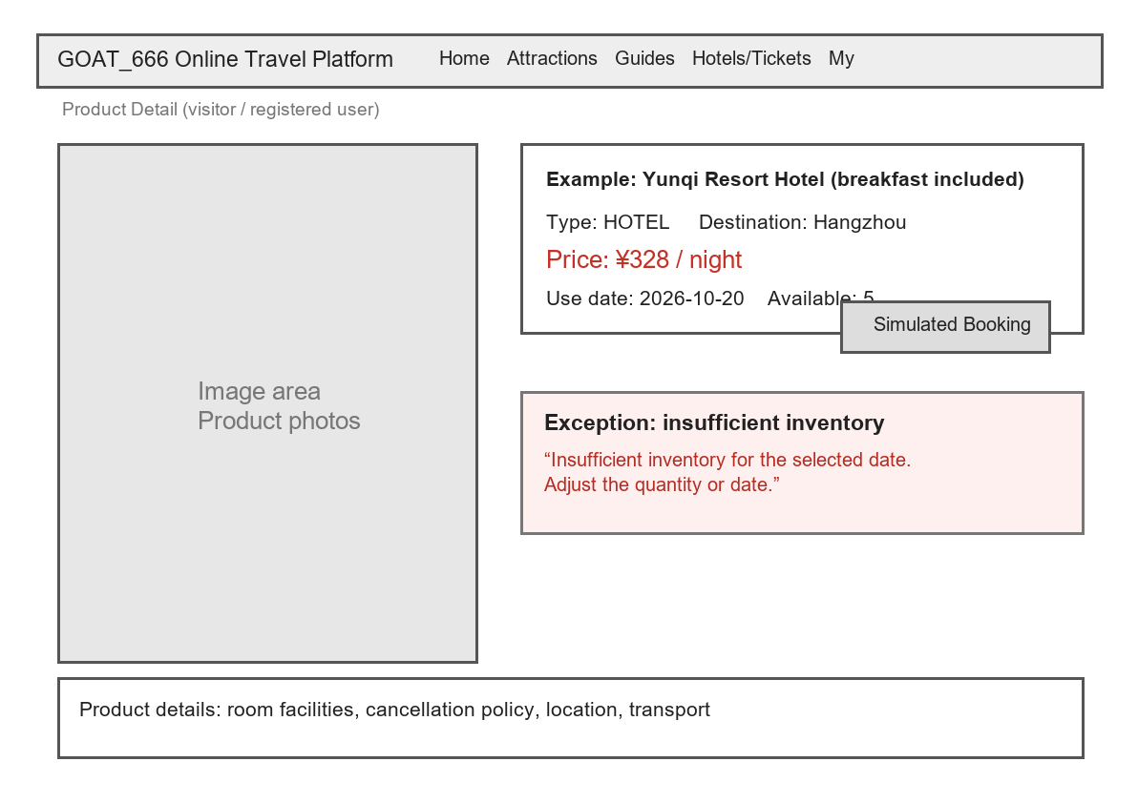
Figure 4-1 Product Detail Page Wireframe (UI-02)

Item | Description
Page ID and Role | UI-02; visitor/registered user
Main Controls and Inputs | Use-date selector (YYYY-MM-DD; only bookable dates), quantity selector (positive integer from 1 to available quantity), [Simulated Booking] button
Action and Navigation | Click [Simulated Booking] → validate → Order Confirmation Page UI-03; not logged in → login
Empty States and Errors | Disable sold-out dates; show insufficient inventory/invalid quantity errors; show a message for delisted products
Related Requirements | SC-02, FR-04, FR-05, AT-F01–AT-F05

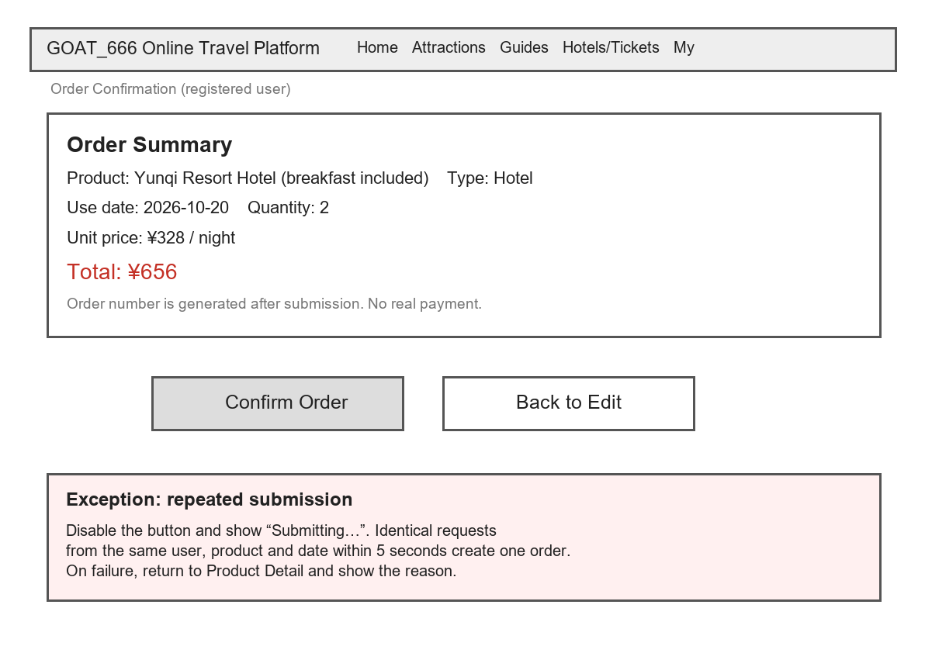
Figure 4-2 Order Confirmation Page Wireframe (UI-03)

Item | Description
Page ID and Role | UI-03; registered user
Main Controls and Inputs | Order summary (product, date, quantity, unit price, total), [Confirm Order], [Back to Edit]
Action and Navigation | Confirm → create order → My Orders Page UI-04; return → Product Detail Page UI-02
Empty States and Errors | Repeated submission: disable button and show “Submitting…”; server-side idempotency creates only one order; on failure return to UI-02 and show the reason
Related Requirements | SC-02, FR-05, AT-F02–AT-F05

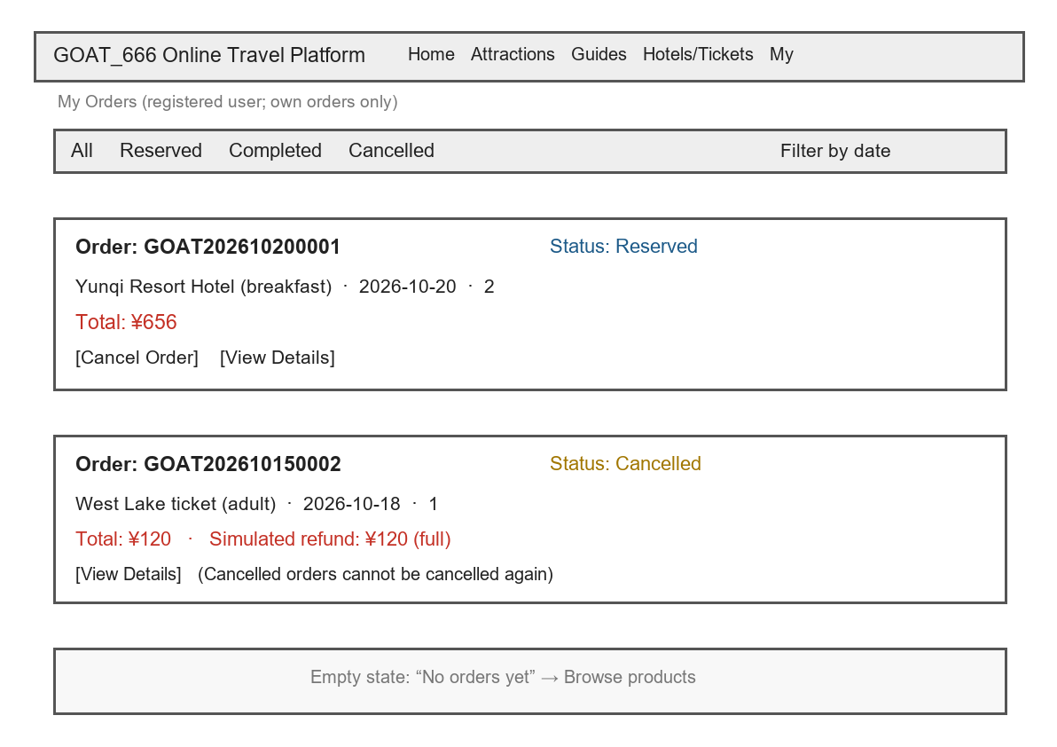
Figure 4-3 My Orders Page Wireframe (UI-04)

Item | Description
Page ID and Role | UI-04; registered user (own orders only)
Main Controls and Inputs | Status filter (all/reserved/completed/cancelled), date range filter, order cards, [Cancel Order], [View Details]
Action and Navigation | Cancel → status becomes “Cancelled” and simulated refund amount appears; details → Order Detail Page
Empty States and Errors | No orders: show “No orders yet” and guide user to browse products; cancelled orders cannot be cancelled again; unauthorized access to another user's order shows access denied
Related Requirements | SC-05, FR-06, AT-F06–AT-F08

Functional Description and Acceptance Verification

Detailed Functional Description
Table 5-1 lists the functional requirement identifiers.
ID | Name | Phase | Lead Role
FR-01 | Account Management | Initial release | D
FR-02 | Browsing Travel Information | Initial release | A
FR-03 | Search | Initial release | A
FR-04 | Hotel and Ticket Product Search | Initial release | B
FR-05 | Simulated Booking (Place Order) | Initial release | B
FR-06 | Order Management (Lookup, Cancellation, Simulated Refund) | Initial release | B
FR-07 | Travel Notes | Initial release | C
FR-08 | Comments, Ratings, Favorites | Initial release | C
FR-09 | Platform Management | Initial release | D
FR-10 | Personalized Recommendations | Extension | A
FR-11 | Content Moderation and Usage Statistics | Extension | D
FR-12 | AI Trip Assistant | Extension | C

Table 5-1 Functional Requirement Overview

FR-01 Account Management
Field | Function FR-01 Account Management
Phase and Roles | Initial release; visitors (register), registered users (log in/log out/edit profile), administrators (assign roles).
Inputs and Format | Username (unique), password (at least 8 characters including letters and numbers), email; profile fields are optional when editing.
Processing Rules | Notify on duplicate usernames; validate password format; manage login sessions; administrator roles are assigned in the administration area.
Outputs and State Changes | Go to the home page after successful registration/login; profile changes take effect immediately.
Exceptions and Access | Provide clear messages for duplicate usernames, invalid password format, and login failures.
Related Items | SC-02, UI-06

FR-02 Browsing Travel Information
Field | Function FR-02 Browsing Travel Information
Phase and Roles | Initial release; visitors/registered users.
Inputs and Format | Browse paginated destination, attraction, and guide lists; detail pages show text and images.
Processing Rules | Destination details show its attractions and guides; attraction/guide details show related products and content.
Outputs and State Changes | List and detail pages; show an empty state when there is no data.
Exceptions and Access | No access restrictions.
Related Items | SC-01, UI-01

FR-03 Search
Field | Function FR-03 Search
Phase and Roles | Initial release; visitors/registered users.
Inputs and Format | Keyword; optional filter (destination/attraction/guide).
Processing Rules | Fuzzy-match titles and summaries by keyword; paginate results; link results to detail pages.
Outputs and State Changes | Results list; show an empty state if there are no results.
Exceptions and Access | Do not search with an empty keyword; show a message.
Related Items | SC-01, UI-01

FR-04 Hotel and Ticket Product Search
Field | Function FR-04 Hotel and Ticket Product Search
Phase and Roles | Initial release; visitors and registered users may use it without logging in.
Preconditions | Product status is “Listed.”
Inputs and Format | Optional filters: destination/attraction (dropdown), product type (hotel/ticket), use date (YYYY-MM-DD). Sort: default/price ascending/price descending. List has 10 items per page.
Processing Rules | 1. Return listed products matching the filters;  2. Show name, type, lowest price, and available quantity for the selected date in the list;  3. Show dates with availableCount = 0 as “Sold out” and make them unselectable;  4. Show description, bookable dates, price, and daily available quantities on the detail page;  5. Use real-time server data for available quantities.
Outputs and State Changes | Product list/detail pages; if no results, show “No products match the criteria. Adjust the filters.”
Exceptions and Access | If a product is delisted, show “This product has been delisted” on the detail page. No access restrictions.
Related Items | SC-01, SC-02, UI-02, AT-F01

FR-05 Simulated Booking (Place Order)
Field | Function FR-05 Simulated Booking
Phase and Roles | Initial release; registered users place orders (visitors must log in first).
Preconditions | User logged in; product listed; available quantity for the selected date is at least the requested quantity.
Inputs and Format | Product (product ID); use date (YYYY-MM-DD, bookable date only); quantity (positive integer, 1 ≤ quantity ≤ available quantity for that date, default 1).
Processing Rules | 1. Check available quantity for the product + date in real time when placing an order; reject if insufficient;  2. In one transaction after validation, deduct the available quantity → create an order with status “Reserved” → create the order item; total = unit price × quantity;  3. Prevent duplicate submission: disable the button and show “Submitting…” after a click. The server handles identical requests from the same user for the same product and date within 5 seconds idempotently, creating only one order;  4. This is only a simulated booking, with no real payment.
Outputs and State Changes | Open the Order Confirmation Page (UI-03) showing order number, details, and total; order status is “Reserved”; available quantity for the date decreases.
Exceptions and Access | Not logged in → login page; insufficient inventory → “Insufficient inventory for the selected date. Adjust the quantity or date”; invalid quantity (0, negative, non-integer, above available amount) → show an error and block submission; delisted product → show a message; duplicate submission → create only one order and show “Order already submitted. Do not submit again.”
Related Items | SC-02, UI-02, UI-03, AT-F02–AT-F05

FR-06 Order Management
Field | Function FR-06 Order Management
Phase and Roles | Initial release; registered users (own orders only). Administrators may view aggregate order data in moderation and statistics (without changing orders).
Preconditions | User logged in; an order belonging to the user exists.
Inputs and Format | Query filters: status (all/reserved/completed/cancelled), optional time range, optional exact order number.
Processing Rules | 1. Return only the user's orders, sorted by order time descending by default;  2. Only “Reserved” orders may be cancelled;  3. Calculate simulated refunds: at least 3 days before use date, 100%; 1–2 days before, 50%; on the same day, 0%;  4. After successful cancellation, change the status to “Cancelled,” record refundAmount, and restore the available quantity for that date by the cancelled quantity;  5. “Completed” and “Cancelled” orders cannot be cancelled again. For a repeat cancellation, show “Order already cancelled; no further action needed.”
Outputs and State Changes | Order list with status labels; order details with items and refund amount; after successful cancellation, show “Order cancelled. Simulated refund of ¥xx returned (simulated).”
Exceptions and Access | Another user's order → show “Access denied” without displaying content  completed/cancelled order → show a cannot-cancel message  nonexistent order → show a message.
Related Items | SC-05, UI-04, AT-F06–AT-F08

Order state transitions are shown in Figure 5-1:
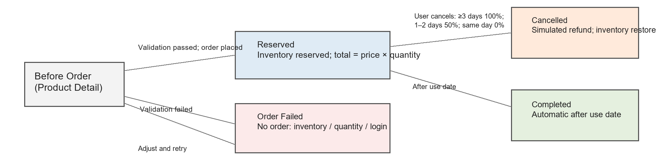
Figure 5-1 Order State Transition Diagram
State notes: If validation fails before an order is placed (insufficient inventory, invalid quantity, or not logged in), no order is generated. A successful order enters “Reserved” (inventory has been reserved). User cancellation changes it to “Cancelled” (a simulated refund is calculated and inventory restored). After the use date, the system automatically marks it “Completed.”

FR-07 Travel Notes
Field | Function FR-07 Travel Notes
Phase and Roles | Initial release; registered users.
Inputs and Format | Title (required, at most 50 characters), body (required), images (at most 5 MB each, up to 9).
Processing Rules | Authors may publish, edit, and delete their own travel notes. Hidden content is not shown publicly.
Outputs and State Changes | A published note appears in the public list; edits/deletions update the list.
Exceptions and Access | Users who have not logged in cannot publish; show a message if image limits are exceeded.
Related Items | SC-03, UI-05, UI-06

FR-08 Comments, Ratings, Favorites
Field | Function FR-08 Comments, Ratings, Favorites
Phase and Roles | Initial release; registered users.
Inputs and Format | Comment (at most 500 characters); rating of 1–5 stars; favorite target (attraction/guide/travel note/product).
Processing Rules | Each user may have at most one rating and one favorite for a target (which may be changed or removed); content moderation affects comment visibility.
Outputs and State Changes | Interaction data appears on the target detail page.
Exceptions and Access | Users who have not logged in cannot act; show a message for a deleted target.
Related Items | SC-03

FR-09 Platform Management
Field | Function FR-09 Platform Management
Phase and Roles | Initial release; administrators.
Inputs and Format | Add/edit/delete forms for attractions, guides, and products; listed/delisted toggle.
Processing Rules | Administrators maintain attractions, guides, and products, and may hide travel notes and comments that violate rules.
Outputs and State Changes | Front-end content updates following administration changes.
Exceptions and Access | Show “Access denied” if a non-administrator accesses the administration area.
Related Items | SC-04, UI-07

FR-10 Personalized Recommendations
Field | Function FR-10 Personalized Recommendations
Phase and Roles | Extension; registered users (new users see popular content).
Inputs and Format | User favorites and content popularity data (internal to the system).
Processing Rules | Recommend attractions and guides based on favorites and popularity; show popular content to new users.
Outputs and State Changes | Display in the home-page recommendation area.
Exceptions and Access | Fall back to popular content if data is insufficient.
Related Items | UI-01

FR-11 Content Moderation and Usage Statistics
Field | Function FR-11 Content Moderation and Usage Statistics
Phase and Roles | Extension; administrators.
Inputs and Format | Comments marked for handling; statistics time range.
Processing Rules | Flag comments for administrator action; show basic usage and order statistics.
Outputs and State Changes | Display on the administration statistics page.
Exceptions and Access | Not visible to non-administrators.
Related Items | UI-07

FR-12 AI Trip Assistant
Field | Function FR-12 AI Trip Assistant (draft, extension)
Phase and Roles | Extension; registered users.
Inputs and Format | Destination (required), number of days, optional preferences.
Processing Rules | Generate trip suggestions based on platform content. The AI does not create or change orders directly.
Outputs and State Changes | Trip suggestion page.
Exceptions and Access | Show a clear message on service timeout or when no usable material is available.
Related Items | UI-08

Input and Output Formats
Object/Action | Input Fields and Constraints | Successful Output | Failure or Empty Result
Product search | Type (hotel/ticket, optional); destination/attraction (optional); date (YYYY-MM-DD, optional); sort (default/price ascending/price descending) | Product list (up to 10 per page): name, type, lowest price, available quantity | No results: “No products match the criteria. Adjust the filters.”
Product details | Product ID; optional date | Name, description, price, bookable dates, daily available quantity | Missing/delisted product: “This product is unavailable or does not exist.”
Simulated order | Product ID; use date (YYYY-MM-DD, bookable); quantity (positive integer from 1 to available quantity) | Order number, items (product/date/quantity/unit price/subtotal), total, status “Reserved” | Not logged in → login; insufficient inventory/invalid quantity/delisted → corresponding message, no order created
Order lookup | Status (all/reserved/completed/cancelled); optional time range; optional order number | Own order list (order number, product, date, quantity, amount, status) | No orders: “No orders yet,” with guidance to browse products
Cancel order | Order ID (own orders only) | Status “Cancelled,” simulated refund amount, available inventory restored | Repeated cancellation: “Order already cancelled; no further action needed”; completed order cannot be cancelled; unauthorized: “Access denied”
Refund rules | Difference in days d between cancellation time and use date (calculated by system) | d ≥ 3: 100% refund; 1 ≤ d < 3: 50%; d < 1 (same day): 0% | —

Interface Acceptance Criteria
Acceptance ID | Page/Control | Action and Conditions | Expected Result | Prototype
AT-UI01 | Home search box | Enter a keyword and click Search | Go to results; show an empty state if none | UI-01
AT-UI02 | Product Detail Page | Select date and quantity and click [Simulated Booking] | Go to order confirmation after validation | UI-02
AT-UI03 | [Confirm Order] on Order Confirmation Page | Click again immediately after the first click | Disable button and show “Submitting…”; create only one order | UI-03
AT-UI04 | My Orders Page | View list after cancelling an order | Status updates to “Cancelled,” refund amount displayed | UI-04
AT-UI05 | Administration Page | Regular user accesses it | Show “Access denied” | UI-07
AT-UI06 | Travel Notes/Personal Center/AI Pages | Check each page when its prototype is complete | Fill in after role C completes the prototypes | UI-05/06/08

Functional Acceptance Criteria
Test ID | Related Req. | Initial Data and Steps | Expected Result
AT-F01 | FR-04 | Listed hotel “Yunqi Resort Hotel” has 5 units available for 2026-10-20; a visitor opens the product list and filters by that date | The list shows the product, quantity 5, and status “Bookable”, an empty-result scenario shows an empty state
AT-F02 | FR-05 | User logged in; product quantity 5; select 2026-10-20 and quantity 2; click [Confirm Order] | Create an order with status “Reserved”; total = unit price × 2; quantity becomes 3; order confirmation shows the order number
AT-F03 | FR-05 | Product quantity 1; submit quantity 2 | Reject the order; show “Insufficient inventory for the selected date”; do not create an order; quantity unchanged
AT-F04 | FR-05 | Submit quantity 0  -1  2.5 | Show “Quantity must be an integer of at least 1”; block submission
AT-F05 | FR-05 | Click [Confirm Order] twice rapidly (less than 5 seconds apart) | Create only one order; on the second click show “Order already submitted. Do not submit again.”
AT-F06 | FR-06 | For a reserved order at least 3 days before use date, click [Cancel Order] | Status “Cancelled”; 100% simulated refund; available quantity restored
AT-F07 | FR-06 | Cancel one reserved order 1 day before use date and another on the use date | Show 50% and 0% simulated refunds, respectively; both statuses “Cancelled”
AT-F08 | FR-06 | User A opens user B's order details directly; cancel an already cancelled order again | Show “Access denied” without order content; for repeated cancellation show “Order already cancelled; no further action needed”
AT-F09 | FR-01–FR-03 | Smoke tests for registration, search, and information browsing | Cover the SC-06 AI trip assistant extension scenario.
AT-F10 | FR-07–FR-12 | Community and extension function tests | Cover the SC-06 AI trip assistant extension scenario.

Process Records and Revisions

Design Decisions, Issues, and Solutions
Issue ID | Issue Encountered | Options Considered | Chosen Approach and Reason | Status
ISS-01 | How should the simulated refund amount be defined? | Option 1: full refund in all cases; Option 2: tiered refund by days before use date | Choose Option 2 (at least 3 days: 100%; 1–2 days: 50%; same day: 0%). It better reflects cancellation costs in real booking scenarios, and the rule can be verified directly in acceptance tests. | Decided
ISS-02 | When should inventory be deducted, and how can overselling be avoided? | Option 1: deduct in the transaction when the order is submitted; Option 2: reserve inventory and release it after a timeout; Option 3: deduct after payment (not applicable to simulated booking) | Choose Option 1: check quantity → deduct → create order in one database transaction; disable the front-end button and use server-side idempotency to prevent duplicates. Reserve the real-payment option for an extension. | Decided
ISS-03 | Repeated clicks on Submit create duplicate orders | Option 1: disable button only on front end; Option 2: disable button plus server-side idempotency | Choose Option 2: disabling the front end prevents ordinary repeated clicks, while server-side idempotency for identical requests by the same user, product, and date within 5 seconds ensures data consistency. | Decided
ISS-04 | How to model “product ownership” in the overall class diagram | Associate hotel products with destinations and ticket products with attractions, or associate both with a general “content object” | Choose the former (refDestinationID  refAttractionID), consistent with product list filters; development team to verify. | Pending review
ISS-05 | Inconsistent identifiers and terms when merging multiple authors' work | Each author uses their own, or agree on an identifier system and glossary first | Choose the latter: establish FR/SC/UI/AT identifiers and the glossary first, then role A checks consistency during integration. | Decided

User Validation Record
People and Date | Validation Task | Feedback or Issue | Corresponding Change/Plan
Planned interviews with 2–3 target users (date to be set) | Review SC-02/SC-05 scenarios and product detail and order page wireframes | Awaiting feedback | Revise scenarios and prototypes based on feedback, then update this document

Note: User validation has not yet been conducted. This is currently a plan, not a completed activity. Update this table after it takes place.

Unfinished Items and Follow-up Updates
Item | Current Status and Reason | Owner | Due Date | Update Location
Home search, travel notes, personal center, administration, and AI page wireframes | Awaiting compilation by role C; no wireframes yet | C | Before 2026-10-18 | 4.2
Detailed acceptance tests for FR-01–03 and FR-07–12 | Awaiting module acceptance points from roles A/C/D | E | Before 2026-10-18 | 5.4
High-fidelity prototypes | Wireframes used instead | C | Extension phase | 4.2
Real user interviews | Planned | Whole team | Before 2026-10-18 | 6.2
Development review of overall class diagram | Backend development members must confirm transaction and inventory approach | B + development | Before 2026-10-18 | 3.1

Requirements Traceability and Consistency Check
Scenario | Functional Requirements | Class Diagram Objects | Prototype | Acceptance Test
SC-01 | FR-02, FR-03 | Destination, Attraction, Guide | UI-01 | AT-F09
SC-02 | FR-04, FR-05 | Product, Inventory, Order, OrderItem | UI-02  UI-03 | AT-F01–  AT-F05
SC-03 | FR-07, FR-08 | TravelNote, Comment, Rating, Favorite | UI-05  UI-06 | AT-F10
SC-04 | FR-09, FR-11 | User (administrator), Comment, Product | UI-07 | AT-F10
SC-05 | FR-06 | Order, Inventory, OrderItem | UI-04 | AT-F06–  AT-F08
SC-06 | FR-10–FR-12 | User, Destination, Attraction, Guide | UI-08 | AT-F11

